[**VISUAL PHYSICS ONLINE**](http://www.physics.usyd.edu.au/teach_res/hsp/sp/spHome.htm)

**THERMODYNAMICS**

**THERMODYNAMICS SYSTEMS**

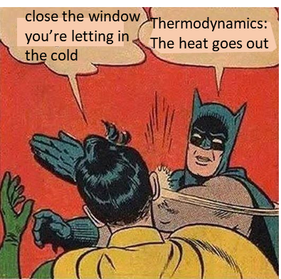

The topic **thermodynamics** is very **complicated** but a topic of extreme importance.

“Thermodynamics is a funny subject. The first time you go through it, you don’t understand it at all. The second time you go through it, you think you understand it, except for one or two points. The third time you go through it, you know you don’t understand it, but by this time you are so used to the subject, it doesn’t bother you any more.”

Arnold Sommerfeld (1868 – 1951 A most famous German physicist)

Ludwig Boltzmann (1844 – 1906) who spend much of his life studing thermodynamics (statistical mechanics), died in 1906 by his own hand. Paul Ehrenfest (1880 – 1933) carrying on the work, died similarly. So did another disciple, Percy Bridgman (1882 – 1961). “Perhaps it will be wise to approach the subject with caution”. David Goodstein

The industrial revolution in the 18th and 19th Century only occurred because of the efforts of made by scientists and engineers in their work on thermodynamics.

**James Watt** (1736 – 1819) was a Scottish inventor, mechanical engineer, and chemist who constructed a steam engine in 1781, which was fundamental to the changes brought by the Industrial Revolution in Great Britain and the rest of the world.

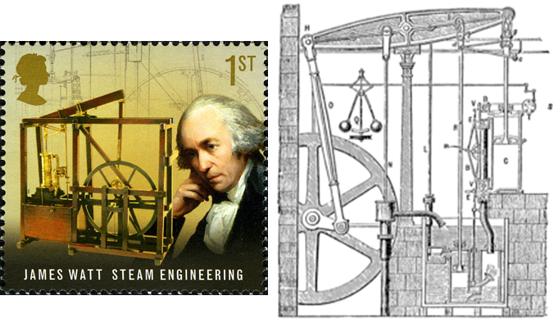

**Count Rumford** (**Sir Benjamin Thompson** 1753 –1814) was an American-born British physicist and inventor whose challenges to established physical theory were part of the 19th century revolution in thermodynamics. He served as lieutenant-colonel of the King's American Dragoons, part of the British Loyalist forces, during the American Revolutionary War. After the end of the war he moved to London, where his administrative talents were recognized when he was appointed a full colonel and in 1784 he received a knighthood from King George III. He was a prolific designer and also drew designs for warships. He later moved to Bavaria and entered government service there, being appointed Bavarian Army Minister and re-organizing the army, and, in 1791, was made a Count of the Holy Roman Empire.

**George Stephenson** (1781 – 1848) renowned as the "Father of Railway” was an English engineer who built the first public inter-city railway line in the world to use **steam locomotives** (The Liverpool to Manchester Railway open in 1830). The Victorians considered him a great example of diligent application and thirst for improvement. His rail gauge of 1435 mm sometimes called "Stephenson gauge" is the standard gauge by name and by convention for most of the world's railways.

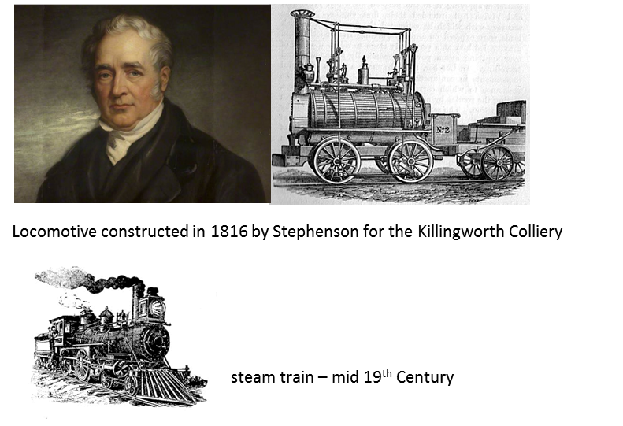

**Nicolas Léonard Sadi Carnot** (1796 – 1832) was a French military engineer and physicist, often described as the "father of thermodynamics". In his only publication, the 1824 monograph Reflections on the Motive Power of Fire, Carnot gave the first successful theory of the maximum efficiency of heat engines.

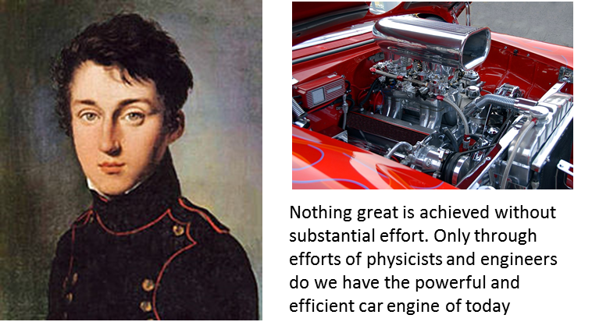

**What do we mean by hot?**

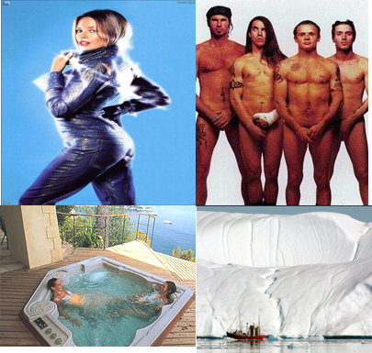

**Why is thermodynamics a complex subject?**

There are many reasons why thermodynamics is complicated. The real-world is complex and every event within the entire Universe and even our thoughts are associated with thermodynamics processes. To model thermal processes, we need to consider both the macroscopic view and the microscopic view (molecular view). Because of the complexity of this topic, the material presented in this Module on Thermodynamics is at a greater depth than that prescribed in the Syllabus. The content statement on Thermodynamics is poorly done and if you covered the material as given in the Syllabus you would have an imprecise and very incomplete knowledge of the workings of the Universe. Without knowing about the concept of **entropy** and the **Second Law of Thermodynamics**, you are not in position to understand thermodynamic process. Just because entropy is a very abstract idea, it should have been mentioned in the Syllabus.

Why do some things happen, while others do not? The answer lies in the Law of Conservation of Energy and the Second Law of Thermodynamics – the total entropy change  of an isolated System is always greater than zero or equal to zero .

A good many times I have been present at gatherings of people who, by the standards of traditional culture, are thought highly educated and who have with considerable gusto been expressing their incredulity at the illiteracy of scientists. Once or twice I have been provoked and have asked the company how many of them could describe the Second Law of Thermodynamics. The response was cold: it was also negative. Yet I was asking something which is about the scientific equivalent of: Have you read a work of Shakespeare’s?

C. P. Snow (1905 – 1980: famous English physical chemist and novelist)

**Every student of physics should have some conceptual understanding of Entropy and the Second law of Thermodynamics.**

The other major reason why studying thermodynamics is complex, is the problem of ***language***. We commonly use the words such as energy, work, heat, heat energy, heat transfer, temperature, hot and cold. The use of these words clash with their scientific use. Colloquially, the word **heat** is often confused with **temperature**. In Physics, these two words are not synonymous.

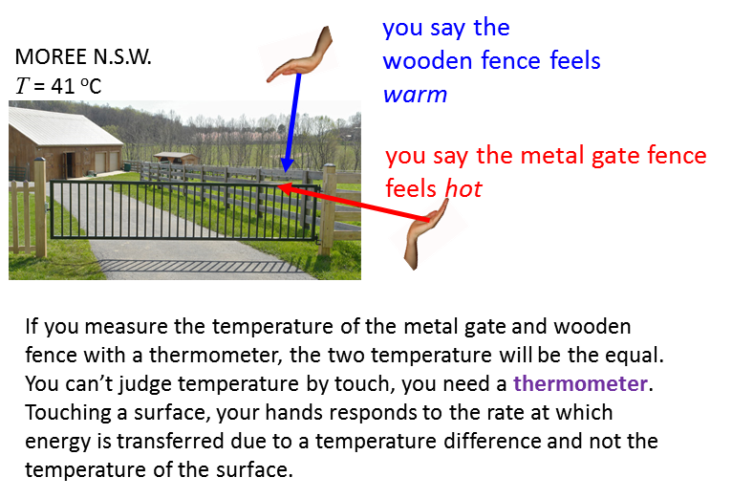

Also, in the development of thermodynamics in the 18th Century, heat was thought to be a fluid substance and could be contained in something. Even today, if you examine 10 books on heat and temperature they will have at least 6 different interpretation of the meaning of heat. Even today, Physicists have difficulty with the scientific language when it comes to the terms heat and heat transfer.

Remember that Physics is not about the real-world. Many approximations and simplifications are necessary in constructing models to describe, explain and predict behaviour of real events. However, often the predictions give numerical results that are in excellent agreement with actual measurements.

Our starting point in the study of thermodynamics is identify the thermal System of interest. A **thermodynamics System** is defined as a collection of many particles such as atoms or molecules. A cup of coffee can be your thermal System or even yourself. In this Module, we will only consider simple thermodynamics Systems.

Thermodynamics in some sense is simple. You can measure a set of parameters of the System at any time and see how they change by the exchange of energy between the System and surrounding environment. We will consider the exchange of energy to and from the System in terms of work and heat .  and  are **not** functions of time. You can’t measure  or  at time t.  and  are simply the causes of the change in the System parameters which are referred to as **state variables**.

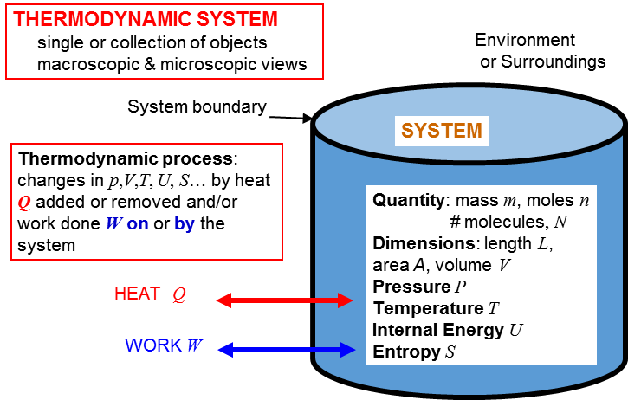

For example, we can take marathon man who melted as our System.

At the end of this Module you will have a good understanding of events leading to the tragedy. You, knowing a bit of Thermal Physics, could save a life. Thousands of people have died in heat wave conditions. People have died just sitting in a sauna. Knowing why, these events maybe be prevented in future. I always thought that the melting man incident was rare. You should do a web search on marathon man who melted and find that it not so rare an incident.

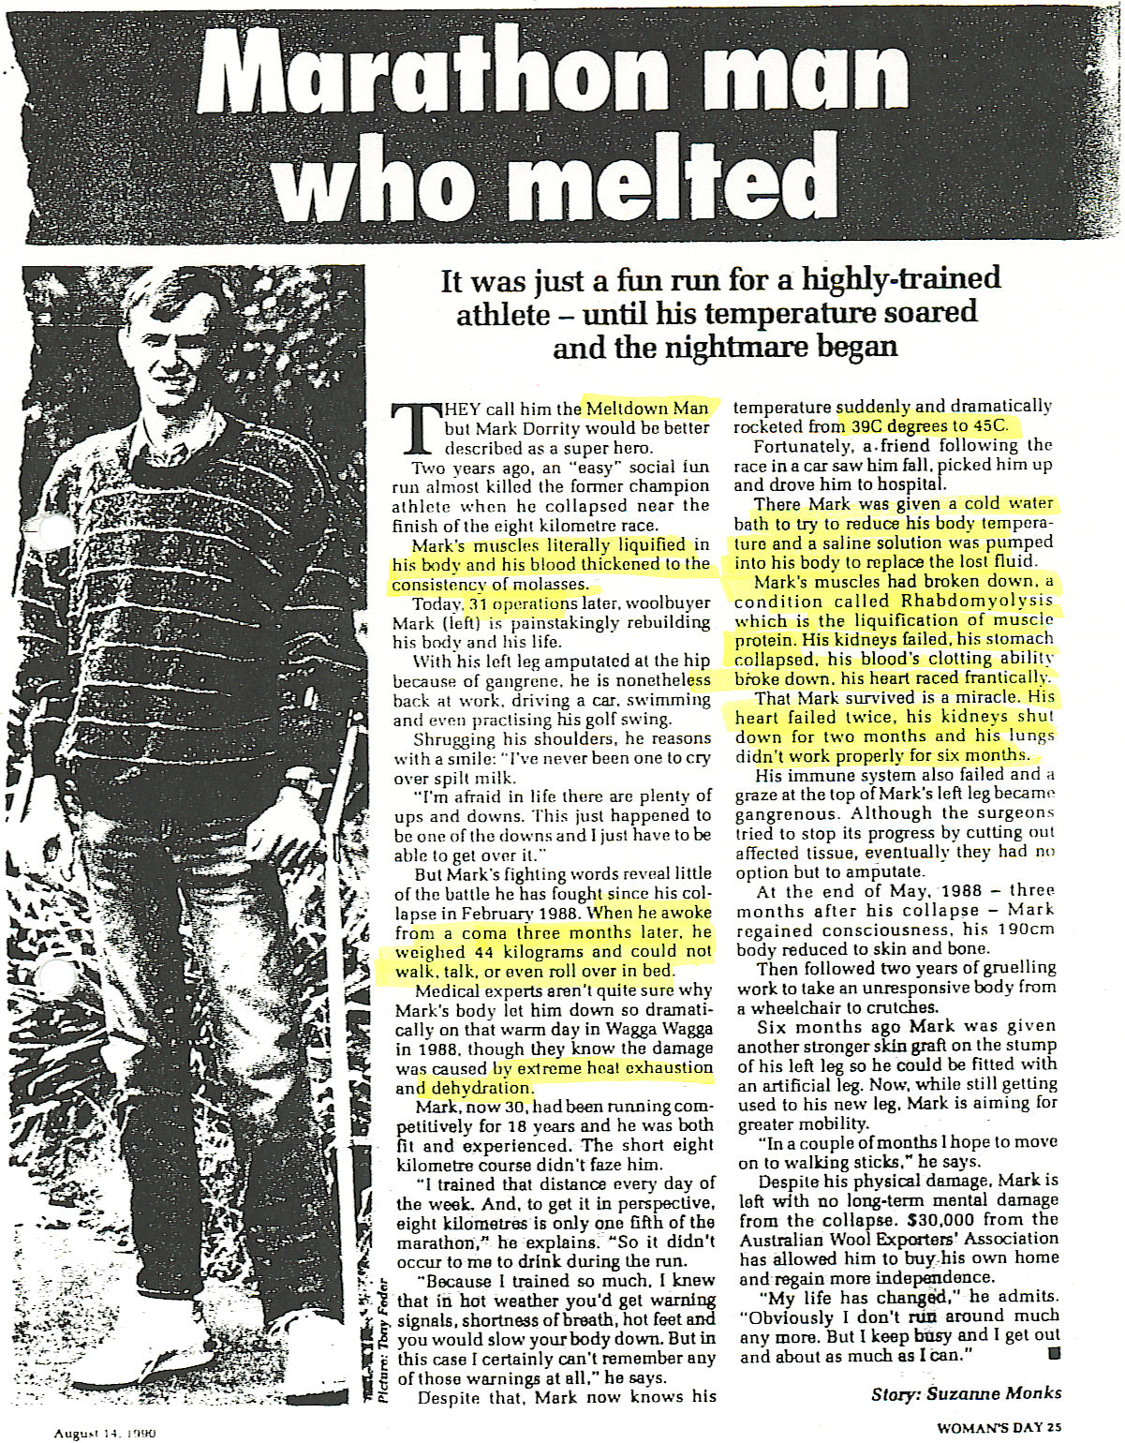

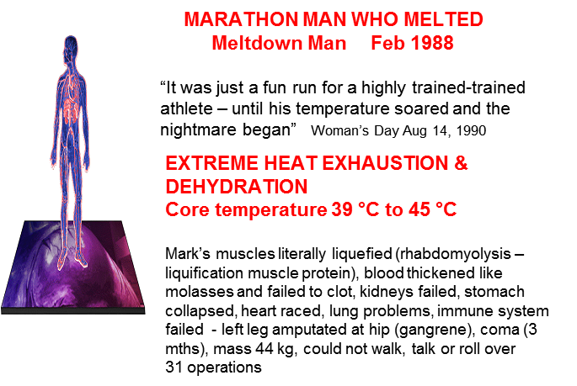

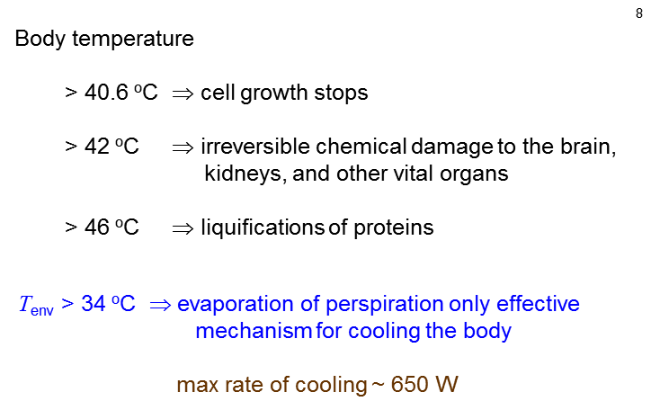

We will consider only Systems which contain solids, liquids and gases. Our System is always at rest, but not the constituents of the System which are always in continual, random (chaotic) motion.

Gravitational, electrical, magnetic, chemical, nuclear effects are all ignored.

A **solid** is a macroscopic System with a definite shape and volume. It consists of molecules connected by spring like molecular bonds. Each molecule is always jiggling about and vibrating around an equilibrium position.

A **liquid** in more complicated than a solid or gas. The molecules are close together as possible, but the molecules are free to move about and deform to fit the shape of the container. The molecules interact through each other by weak molecular bonds.

A **gas** is a System in which each molecule moves through space as a free noninteracting particle which often collides with other molecules and the walls of the container and in the process, there are exchangers of energy. The gas fills the container.

These three states of matter are referred to as **phases**. Phase changes occur for example, when a solid melts to form a liquid.

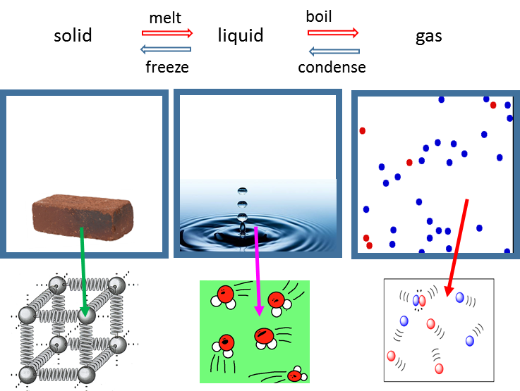

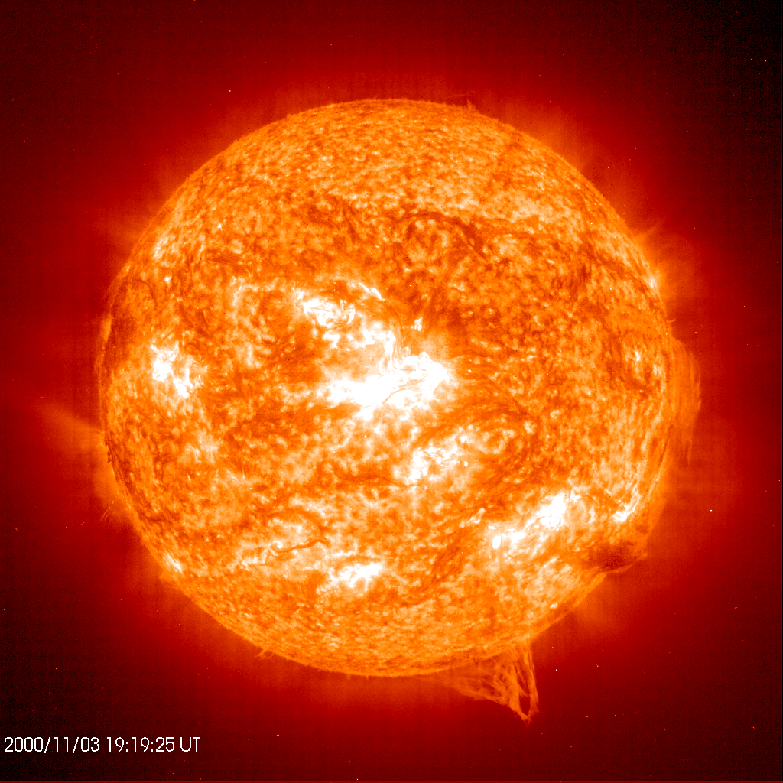The fourth state of matter is a plasma. It is the most prevalent phase of matter in the Universe as a whole. The Sun and other stars are mainly plasma. A plasma is a neutral gas comprising charged particles of positive ions and free electrons: the atoms are ionized by being stripped of their electrons.

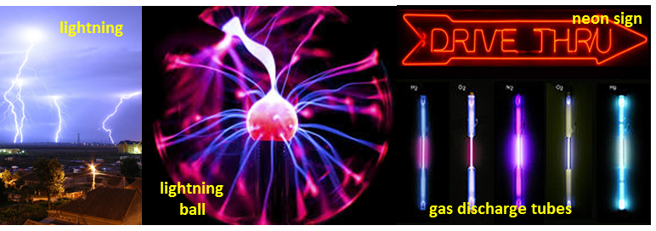

**INTERNAL ENERGY THERMAL ENERGY**

A thermodynamic System is composed of molecules in a solid state and/or a liquid and/or a gas state. The molecules always have some **random** or **chaotic motion**. Therefore, the System has a kinetic energy due to this random and chaotic motion. The kinetic energy is often classified as **translational kinetic energy** (movement of molecules from one place to another), **rotational kinetic energy** (rotation of molecules about the XYZ axes) and **vibrational kinetic energy** (period vibrations of the molecules).

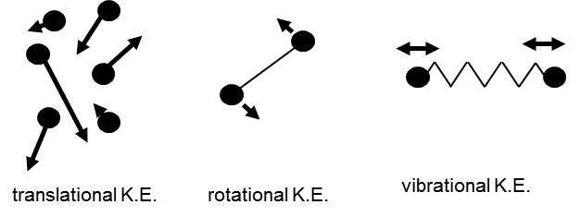

There are attractive and repulsive forces acting between molecules often giving rise to molecular bonds. Therefore, the System has **potential energy** due to these interactions.

The total sum of all the kinetic energies of the molecules together with the potential energies of the System is called the **internal energy**  of the System. It is a state variable and its value can change with time in response to the exchange of energy between the System and the surrounding environment through the processes of **work** and **heat**.

Often **internal energy** is also called **thermal energy**. However, sometimes, thermal energy has a much broader interpretation. Even physicist can’t agree on the language to be used in thermal physics. The best approach for you to consider the internal energy as the sum of the kinetic energies and potential energies for the System and use thermal energies as a broader term that is closely related to internal energy.

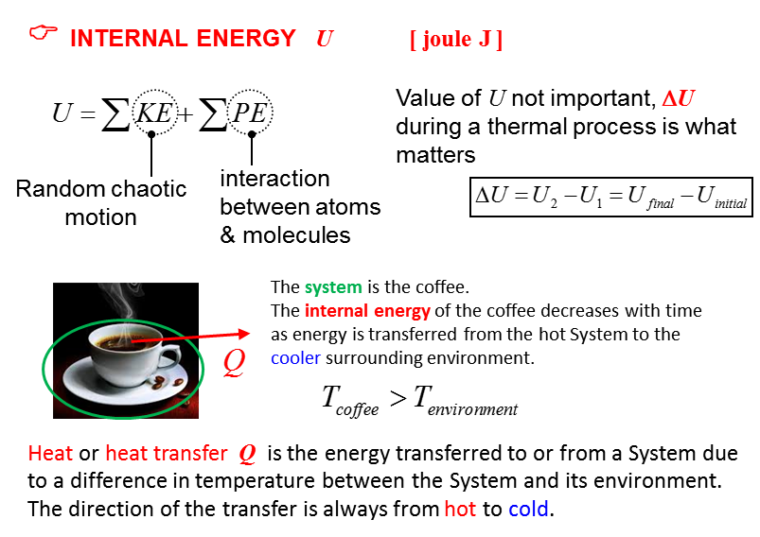

The internal energy of an isolated system is constant. Internal energy is **not** a form of energy but a way of describing the fact that the energy in atoms is both stored as potential and kinetic energy. It does **not** include kinetic energy of the object as a whole or any external potential energy due to actions of external forces or relativistic energy (*E=mc*2).

**What do we mean by the term TEMPERATURE ?**

Temperature is a concept with which you are very familiar, it’s the sense impression that allows you to differentiate between **hot** and **cold**. Temperature is not a term that can be defined precisely and scientifically.

**The temperature of a System is the degree of hotness or coldness of the System as measured on a temperature scale using a thermometer.**

The scale is based upon a **thermometric property** of matter that varies with temperature in a way that is reproducible (pressure, volume, electrical resistance, emitted EM radiation, emf - electromotive force). The thermometric property relates to the type of **thermometer** used to measure the temperature.

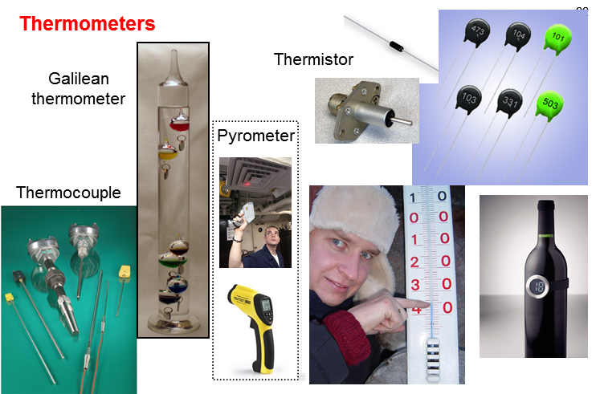

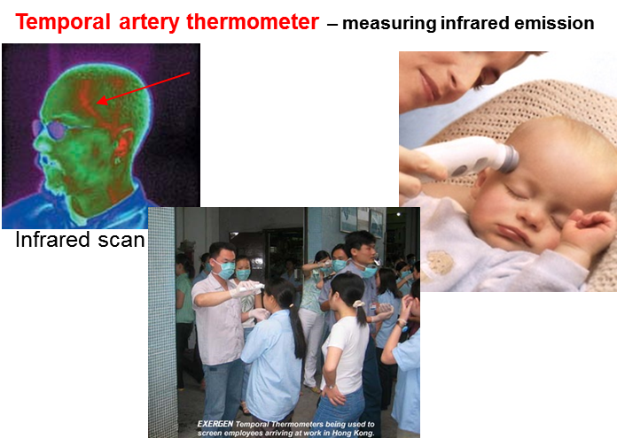

The most common temperature scale used is the **Celsius Temperature Scale** and was formally based upon the melting and boiling points of water at atmospheric pressure

0 oC melting point (mixture of ice and water)

100 oC boiling point (mixture of water and steam)

The S.I. unit for temperature is the **Kelvin Temperature Scale**

a change in 1 °C = 1 K Kelvin K





The lowest temperature on the Kelvin scale is 0 K and is referred to as **absolute zero**. Absolute zero is theoretically the lowest possible temperature of a System. At absolute zero, the internal energy of a System is at its absolute minimum value but it still is greater than zero. In practice, the temperature of a System is always greater than 0 K.

In calculations involving a temperature difference , you can use either the Celsius Scale or the Kelvin Scale. However, using an equation with temperature  you must use the Kelvin Temperature Scale.

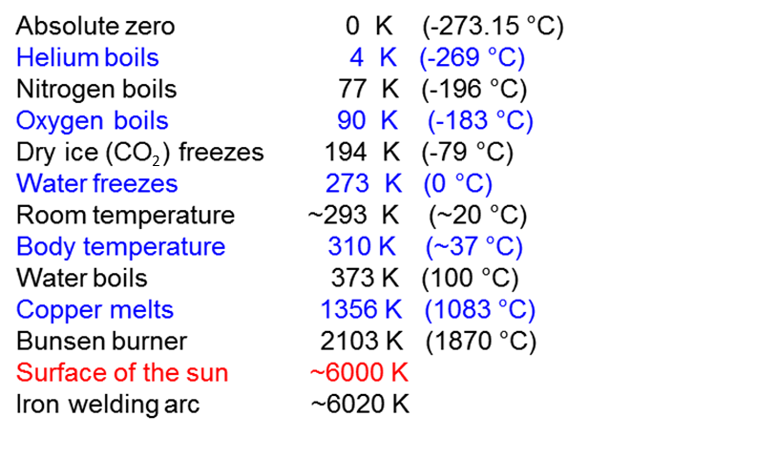

The temperature of a System determines the System’s tendency to transfer energy.

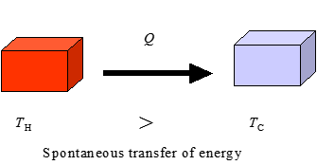

**Heat transfer will of itself always flow from a region of higher to lower temperature**

**Heat**  refers to the amount of energy transferred due to a temperature difference. Heat is a happening not a substance (heat is not contained in something). The term heat should only be used in relationship to the transfer of energy. You should **not** use the phrase *heat is a form of energy*. **Heat is not a form of energy** but the energy transferred due to a temperature difference. Heat is not a function of time. You can only specify the amount of energy that has been exchanged between Systems or between a System and its surroundings.

temperature of System 

temperature of surrounding environment 

energy is lost from the System to its surroundings  internal energy  of System decreases

 energy is gained from the System’s surroundings  internal energy  of System increases

Two Systems are in **thermal equilibrium** if and only if they are at the same temperature. An **isolated System** is one with no interaction with its surroundings (insulating walls). Two isolated systems brought into thermal contact and allowed to exchange heat with each other (but not with their surroundings) will, after a “long time” be in thermal equilibrium.



**Zeroth Law of Thermodynamics**

If a can of coke and a bottle of milk each have the same temperature as the inside of your refrigerator, then the coke and milk have the same temperature as well. This trivial observation is called the **Zeroth Law of Thermodynamics**.

**If Systems A and B each are in thermal equilibrium with a third System C, then A and B are in thermal equilibrium with each other.**

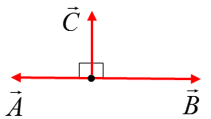This law seems trivial, but it is not so obvious if you consider the following example. If vectors  and  are each perpendicular to a vector , this fact does **not** necessarily mean that  is perpendicular to .

**Microscopic view of Temperature**

At the microscopic (atomic) level, the temperature of a System depends upon the internal energy  of the System



If energy is added to a System through the processes of **heat** and/or **work** then the internal energy of the System  will increase:

* If the average translational kinetic energy  of the System increases, then the temperature  of the System will also increase.

* If the average translational kinetic energy of the System does not increase, but potential energy  increases, then a change in phase (state) may occur.

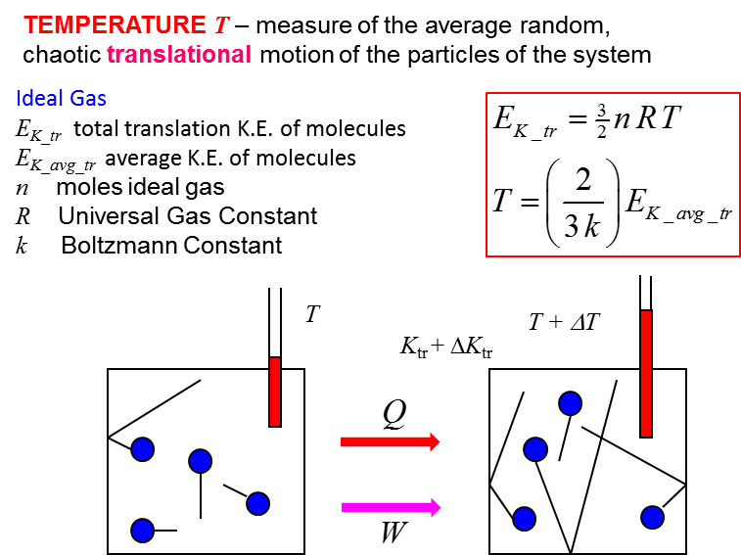

For an ideal monoatomic gas, the temperature  is directly proportional to the average translational kinetic energy  of the molecules of the gas.

Thus, on a microscopic level, the **temperature of a gas is a direct measure of the average translational kinetic energy**. A higher temperature corresponds to higher molecular speeds. At absolute zero, , all molecular motion ceases in our classical theory, but using more advanced theories, quantum effects prevent this from happening – molecule can never have zero energy.

**ENTROPY S [ J.K-1 ]**

The **entropy**  of a System is related to the amount of disorder in a system. The entropy is a state variable and the change in the value of the entropy is important and not the actual value of the entropy.

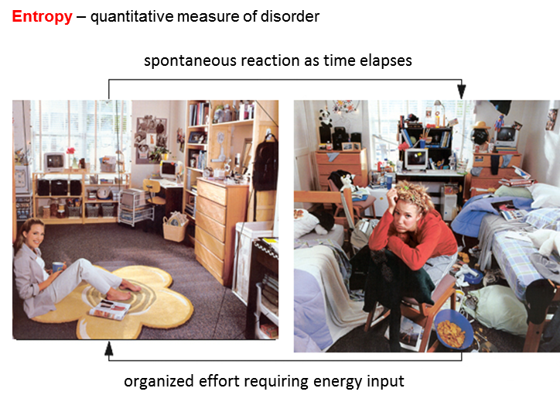

**Entropy in the Universe / Second Law of Thermodynamics**



The total entropy of the Universe stays the same whenever a reversible process occurs.



The total entropy of the Universe increases whenever an irreversible process occurs.



All real processes are irreversible. Hence, the total entropy of the Universe continually increases. In terms of entropy therefore, the Universe moves only in one direction – towards ever increasing entropy. the Second law of Thermodynamics gives the “arrow of time” ever-present in nature.

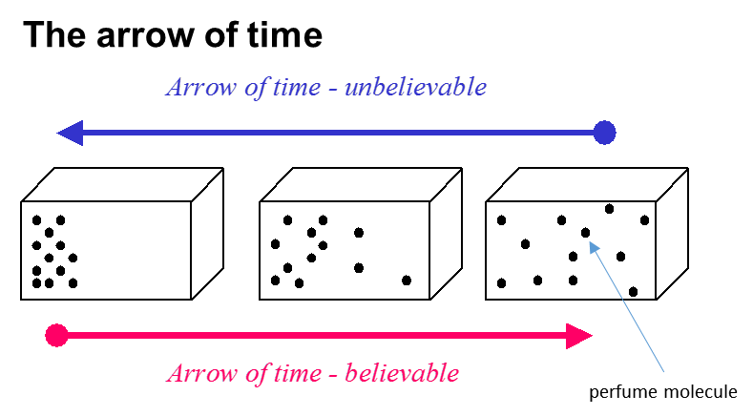

You open a perfume bottle – the perfume gradually spreads throughout the room – it is very unlikely due to the random movement of the perfume molecules that they would all accumulate back into the bottle. When the perfume molecules are in the bottle, it is an ordered arrangement. The molecules move in such a way to increase their disorder and hence increase the entropy.

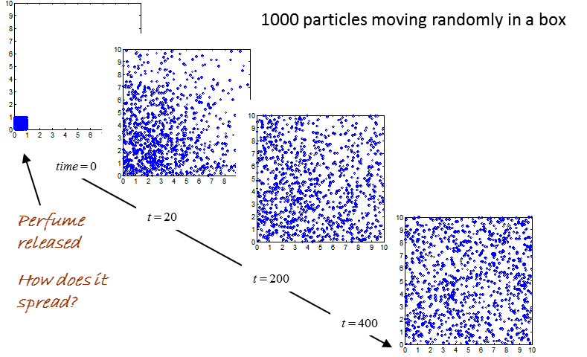

[VIEW ANIMATION](http://www.physics.usyd.edu.au/teach_res/mp/doc/tp_equilibrium.htm)

Entropy and disorder relate to **probability**. Each individual arrangement of the perfume molecules has exactly the same probability of occurring, but there are only a few ways you can arrange for the molecules to be in the bottle and a much greater number of ways to arrange the molecules to fill the room. So, the time evolution for the location of the molecules will be from a situation of lesser to greater probability.

This leads to a natural order in which events will evolve in nature.

**Entropy increases, energy becomes less available, and the universe becomes more random or more “run down”.**

There are no phenomena whereby a System will spontaneously leave a state of equilibrium. All natural processes proceed in such a way that the probability of the state increases – law of increasing entropy – it is one of the most important laws of nature – the Second Law of Thermodynamics

***Why does a block of ice melt?***

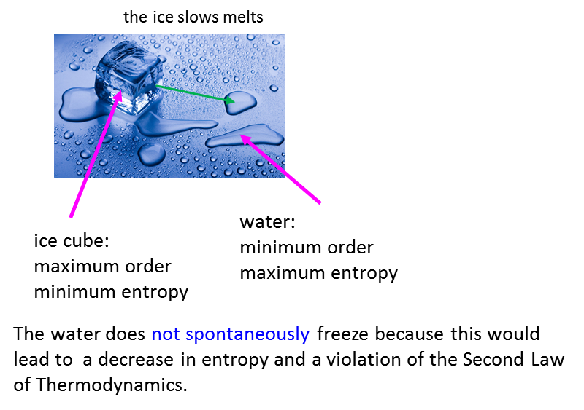

**So why does the energy spontaneously transfer from a hot System to a cold System?**

It is just like the perfume bottle, there are more ways to arrange the gas molecules in a larger volume than a smaller volume. When the two Systems at different temperature are bought into are in thermal contact, the temperature of the two systems will evolve to equilibrium when the two Systems have the same temperature. This occurs because there are more ways in which the kinetic energy can be distributed between all the molecules of the two Systems rather than fewer particles having greater kinetic energies in one of the Systems.

We have two bricks, one hotter than the other. The molecules in the hot brick have more kinetic energy on average than the average kinetic energy of the molecules in the cold brick. This means that the System of the two brick is rather ordered - the hot brick has the high kinetic energy molecules and the cold brick has the low kinetic energy molecules.

The bricks are bought into thermal contact and energy is transferred from the hot brick to cold brick (heat ) until we have thermal equilibrium where the two bricks have the same temperature.

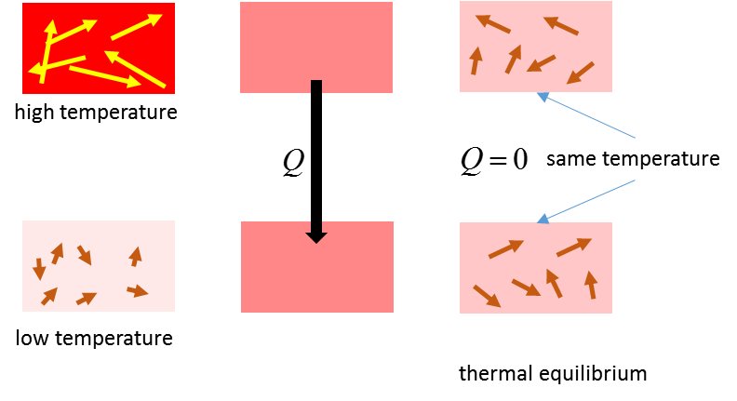

During the heat transfer, the entropy of the universe increases as the ordered pattern for the distribution of the kinetic energies of the molecules becomes more random and disordered. If heat was transferred from the cold brick to the hot brick, the distribution of the kinetic energies would become more ordered and this is a contradiction of the Second Law of thermodynamics.

**Heath Death of the Universe**

The disorder of the Universe continually increases and as it does, the amount of energy available for useful work decreases. So, one possible fate is the death of the Universe as heat from hot to cold leads to all objects in the Universe being at the same temperature, so no energy is available to do work and no physical processes can occur.

**Car Engines**

A car engine efficiency is always less than 100% because of the Second Law of Thermodynamics. It is impossible to convert all the heat energy from burning the petrol into useful work in moving the car.

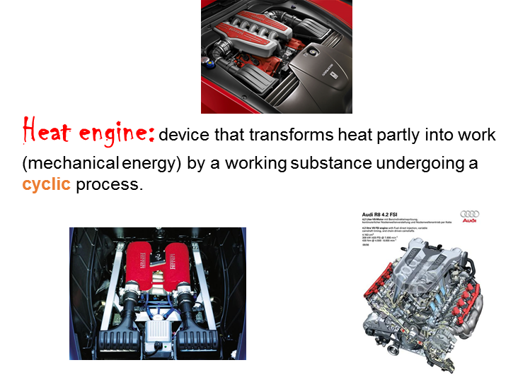

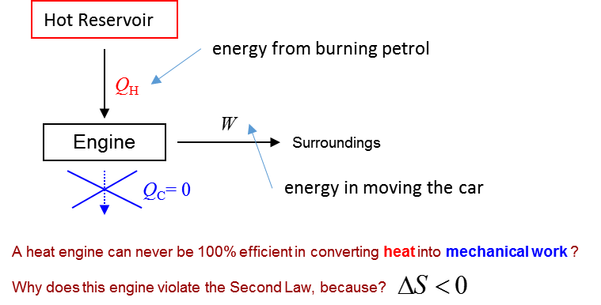

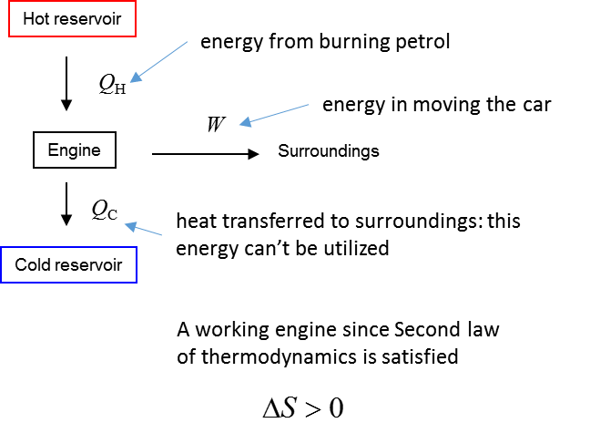

**Macroscopic view of entropy**

An approximate value for the change entropy  of a System at a temperature when energy  is transferred due to a temperature difference is given by



**Example**

System A at a temperature of 600 K transfers 1200 J of heat to System B which is at a temperature of 300 K. Find the change in entropy of the “universe”.

**Solution**



The entropy of System A decreases



The entropy of System B increases



The change in entropy of the universe is



The spontaneous transfer of energy must be from the hot System to the System at a lower temperature, otherwise, it would be a violation of the Second Law of Thermodynamics .

**FIRST LAW OF THERMODYNAMICS**

The **First Law of Thermodynamics** is a statement of energy conservation that specifically includes heat transfer (heat) and work.

Heat is only involved in a process that occurs when there is a temperature difference, rather than being a characteristic property of either system (heat is not a state variable). It is often better to use **heat transfer** rather than the single word heat.

**Heat transfer can be considered both the amount of energy transferred as well as the process itself.**

If heat  is transferred to a System, the internal energy  increases. If this System does work  on the surrounding environment, this energy must come from the internal energy of that System.

The **First law of Thermodynamics** (a law of conservation of energy) is

 **First Law of thermodynamics**

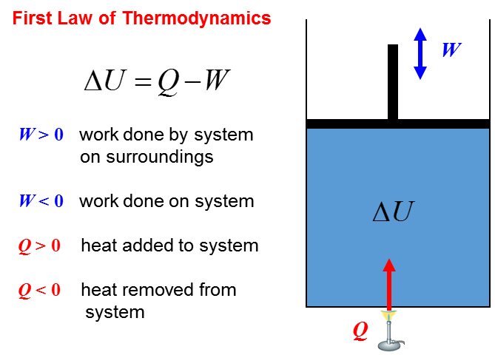

**Example**

Running along the beach on the weekend, you do 4.8x105 J of work and give off 3.7x105 J of heat. (a) What is the change in your internal energy? (b) When walking, you give off 1.5x105 J of heat and your internal energy decreases by 2.3x105 J. How much work have you done whilst walking?

**Solution**

The person is the System

Apply the First Law of Thermodynamics 

Draw an animated scientific diagram

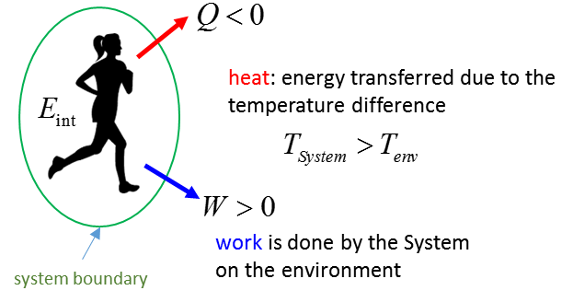

(a) 

(b) 

The internal energy  is a very different quantity to heat  and work . Heat  is the amount of energy exchanged because of a temperature difference between Systems when in thermal contact or a System and its surrounding environment. Work  indicates a transfer of energy by the action of a force through a distance. The internal energy  is a state variable that depends on time and upon the state of the System and not how it was brought to that state.

**Example**

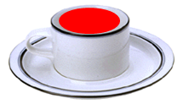Consider a hot cup of coffee sitting on a table as the System. Using this System as an illustration, give a scientific interpretation of the terms: temperature, heat, work, internal energy, thermal equilibrium.

**Solution**

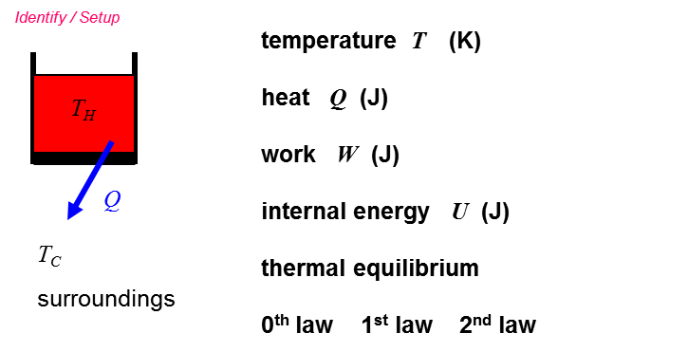

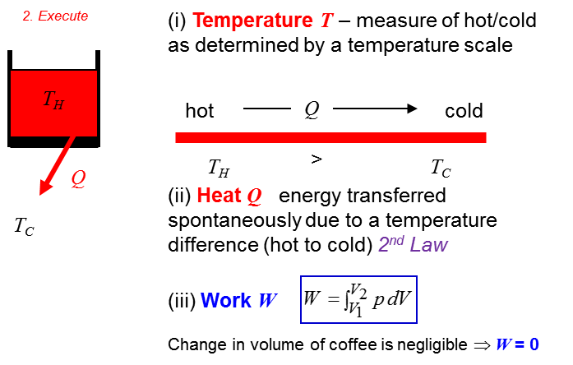

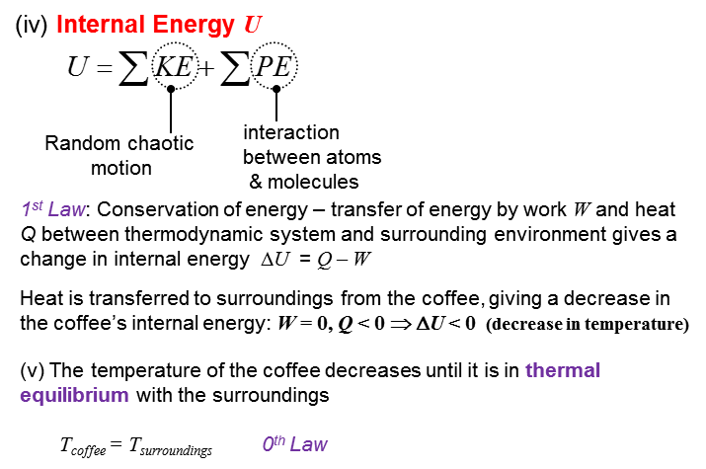

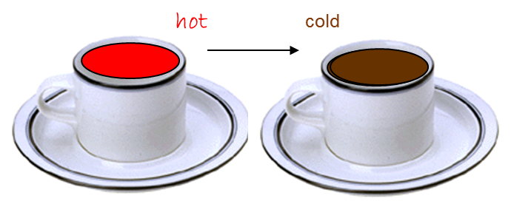

**Conservation of Energy Involving Friction**

Consider a block that is given an initial velocity  on a horizontal surface. The block comes to a stop due to the frictional force acting on it (coefficient of kinetic friction ). Let the System be the block + surface. The external net force acting on the System is zero, therefore, we have an isolated System.

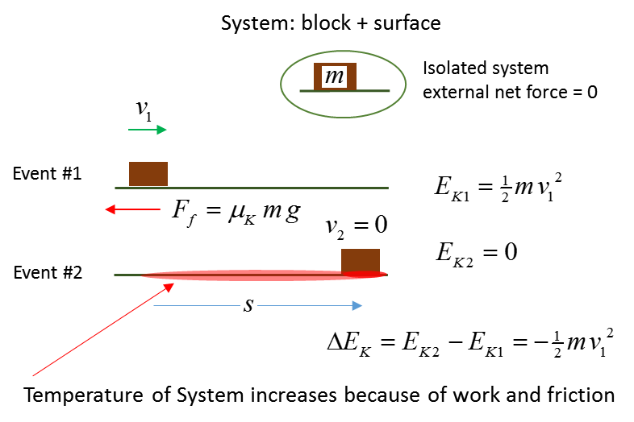

Since we have an isolated System there is zero transfer of energy into or out of the System. Since energy cannot be created or destroyed,

where did the decrease in energy (kinetic) of the System go?

The decrease in energy (kinetic) of the System shows up as an increase in the internal energy of the block + surface System and the temperature of the system will increase.



The temperature of the System increases without any heat input. The temperature rise comes from friction and work.

A very good example of an increase in temperature of an object without heating is when a cricket ball is struck by a bat. During the impact of bat and ball, kinetic energy is lost and the internal energy of both bat and ball increase, therefore, the temperature at the impact points of bat and ball increases. This is shown clearly in the thermal imaging of the impact of bat and ball. The image in cricketing terms is called “**hot spot**”. All objects because of their temperature, emit electromagnetic radiation (mainly infrared), the hotter the surface the more radiation is emitted at shorter wavelengths.

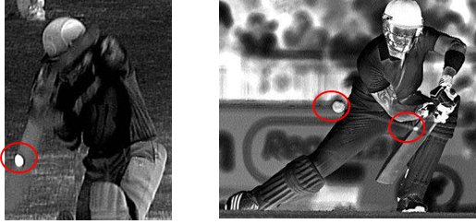

**METHODS OF HEAT TRANSFER**

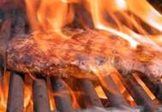

Heat can be exchanged in a variety of ways. The Sun, for example, warms us from across 149.6 million km by a process known as **radiation**. As sunlight is absorbed by the ground its temperature increases, the air near the ground gets warmer and begins to rise, producing a further exchange of energy by **convection**. As you walk across the hot ground in bare feet, you feel a warming effect as heat enters your body by **conduction**. In the following units, we look further into the processes of

**radiation convection conduction**

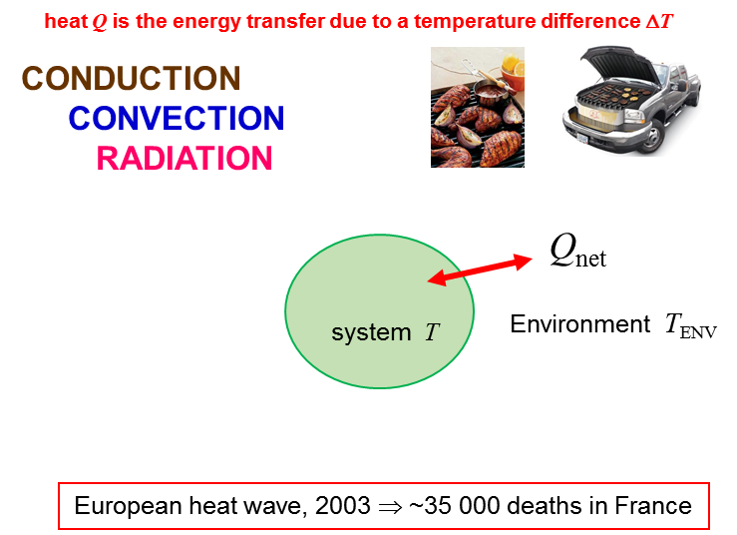

**Thinking Questions**

How are the methods of heat transfer related to the live sheep trade?

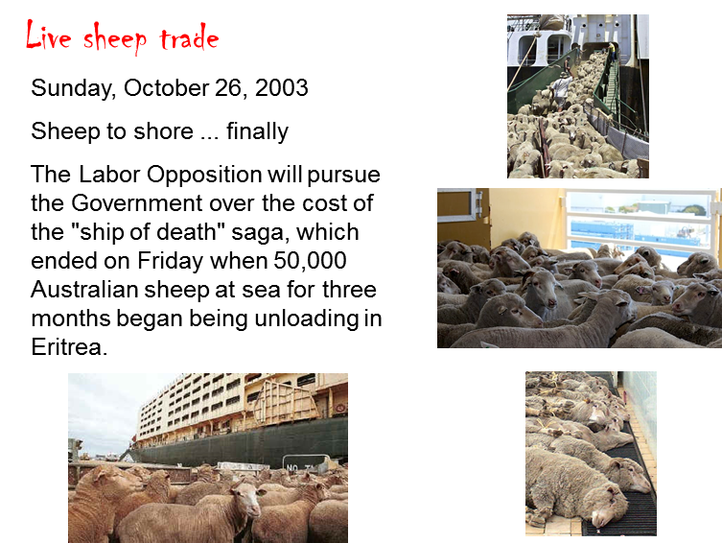

Identify all the methods of heat transfer from the two images

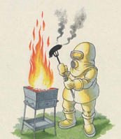

[VISUAL PHYSICS ONLINE](http://www.physics.usyd.edu.au/teach_res/hsp/sp/spHome.htm)

If you have any feedback, comments, suggestions or corrections please email:

Ian Cooper School of Physics University of Sydney

ian.cooper@sydney.edu.au